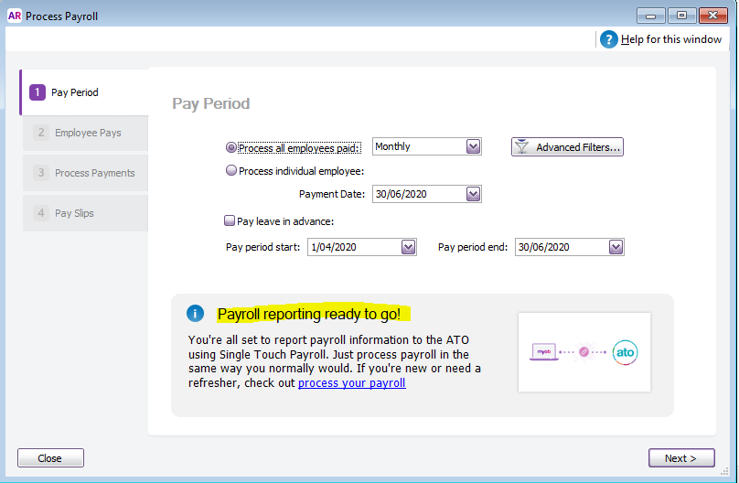
Figure 1 MYOB AR Server edition Version 2020.2 Admin user set up the payroll. From this screen I record the payments.
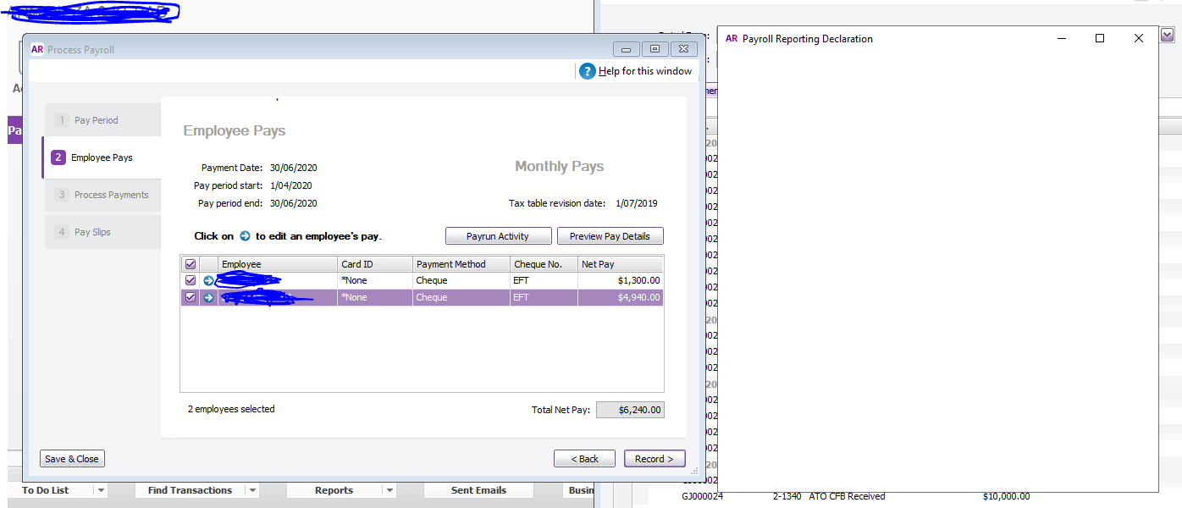
Figure 2 After making payments, I click Record. Declaration page opens but does not display anything. How long I wait it does not drop or proceed. On the Admin user, the declaration page displays and processes without any problem.

