Invoice Entry
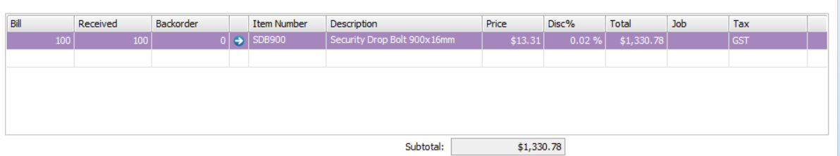
Recap

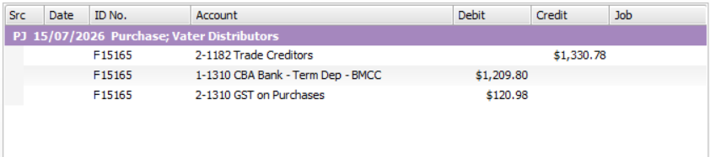

Item Card Data

